AVOCA BOROUGH – 2026 RECYCLING SCHEDULE AND INFORMATION
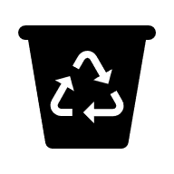 Recycling
The recycling truck is available to residents every Wednesday and Thursday from 8am to 8pm at our Municipal Garage located at 1103 Plane Street. Recycling is encouraged although not mandatory.
Commingled recyclables such as glass bottles, jars, cans and household plastics (Plastic #1 & 2) will be accepted every Wednesday and Thursday.
Cardboard and newspaper /junk mail will alternate weeks, as indicated on the calendar, to help prevent “pile ups” and having the truck overfilled.
VERY IMPORTANT!!! Please follow the recycling schedule, so as not to mix cardboard and newspaper. Please make sure to rinse out bottles, jars, etc. so other recyclables are not contaminated – contaminated items are deemed “unrecyclable” and will be refused.
 Yard Waste
Yard waste is collected every Tuesday during the season.
Season begins April 14, 2026 and will end November 24, 2026 (weather permitting).
Each household is allowed up to (3) three standard size, open containers or paper bags. The containers shall not exceed 30 pounds. Grass clipping, leaves, shrubs, hedge clippings and tree limbs (max 3ft in length) will be collected. Please do not put yard waste in plastic bags or the extra large garbage cans with attached lids.
Place yard waste curbside on Monday night to ensure pick up on Tuesday. If you have any questions regarding yard waste, please contact the Borough Office at (570)457-4947 ext. 3.
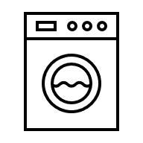 White Goods
White goods pick up will be: Wednesday, July 15, 2025
Acceptable items include washers, dryers, stoves, hot water heaters, dishwashers, refrigerators & freezers (with doors removed), air conditioners and grills. NO Electronics will be collected.

